Documentation of WRO Future Engineer 2023



By Team YBR-GPA4.0

This document contain:
- Team member and the vehicle
- Engineering information
  - Movement management
  - Power management and checking
  - Obstacle evading
  - Engineer factors
- Github Link
- YouTube Link

Team members
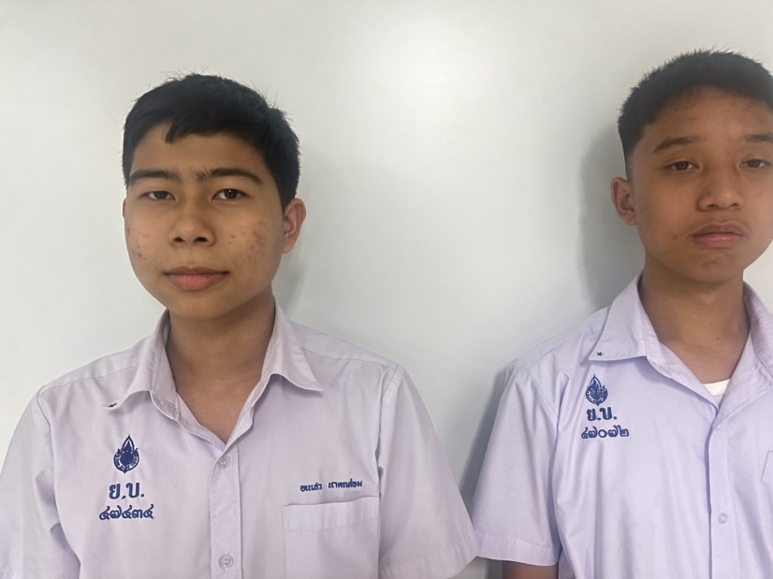

Left side is Mr.Vorawet Narkglom ,15 years old, who is grade 10 and study at Yothinburana School English Program. The main programmer and the mechanic of our team
Right side is Mr.Vichaiwat Koonsap ,15 years old, a grade 10 and currently studying at Yothinburana School in the Regular Program. The co-Programmer and the main mechanic of our team.

Robot photos
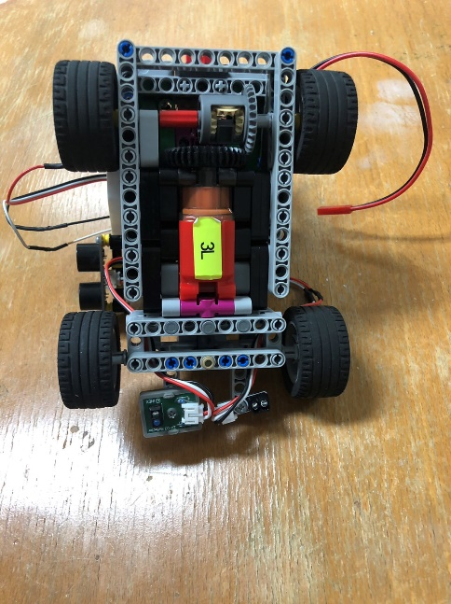
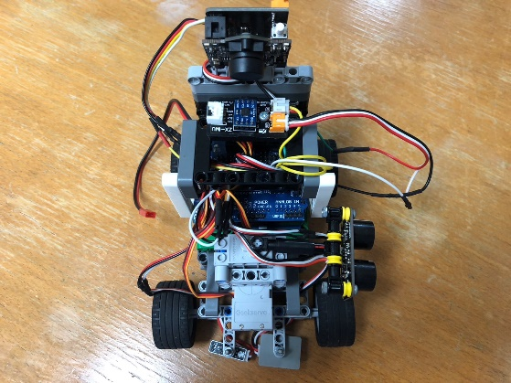
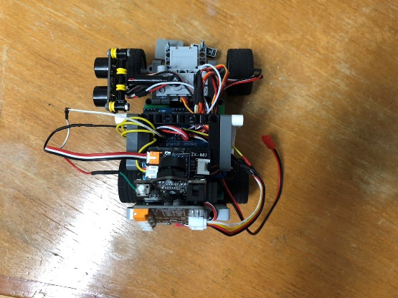

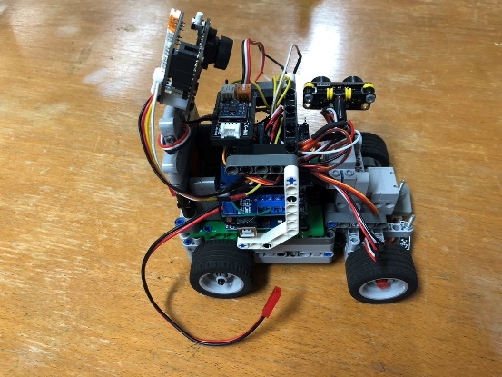
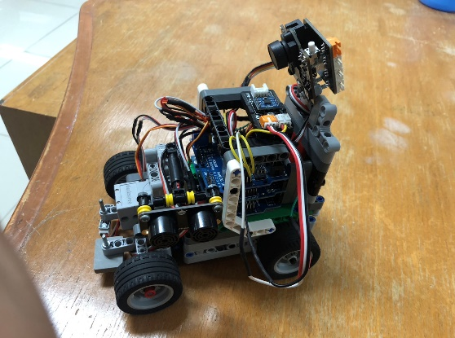

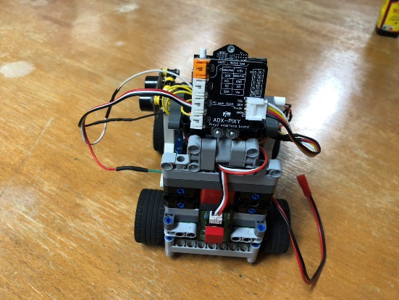

2. Engineering information
2.1 Movement management

- Power Functions Large-Motor by LEGO for driving motor
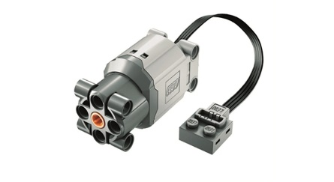
A fast and incredibly user-friendly motor. Just a few minutes of soldering the wires, and we are ready to use it. Among all the motors, we chose this one because it is neither too fast nor too slow, and it is quite easy to attach to the robot frame. It can be adjusted for Lego and Arduino by soldering.

Technical Information
This is large motor, it delivers a maximum torque of 45,4 mNm (450mA). Without load its rotation speed is around 380 rotations per minute

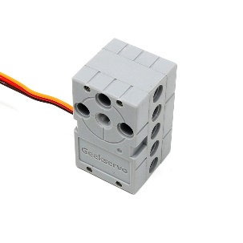
- GEEKSERVO-270 a 180 degree servo for steering motor
We chose this servo because it is pretty easy to attach to our robot frame and got the right degrees, we needed to use for steering which is 180 degrees.

Technical information
-Rotation: 180 Degree
-Start Voltage: 2.5V
-Working Voltage: 3.3-6.0V
-Rated Voltage: 4.8V Our Steering Servo rotation code
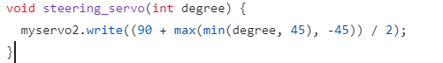
-Rated Current: 100mA
-Stall Current: 550mA
-Stall Torque (max): 500g.cm
2.2 Power management and checking

- We use 2 type of color sensor with two different color: ZX-03 by inex with the blue color and Virus III by designed by sopon with the red color
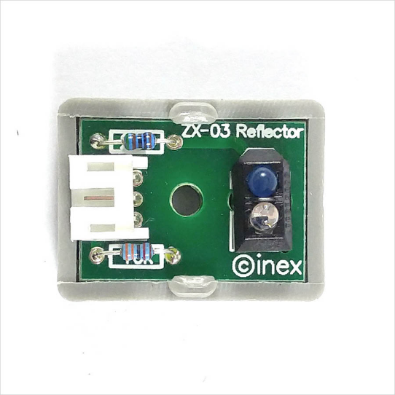

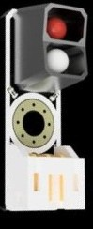

ZX-03 blue color Virus III red color

Light sensors play a crucial role in helping robots know where to stop and give order to other component. But what's interesting is that we use two different colors for these lines: red and blue. This choice lets the robot not only see the lines but also figure out whether they are red or blue. This extra bit of information helps the robot know how many times it have orbit around the race field, making it smarter and better equipped for the race.

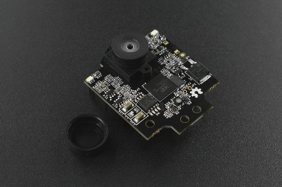
- PIXY version 2.1 for camera
The camera serves the purpose of identifying color blocks (obstacles) and transmitting corresponding signals to the robot.
Software and Library: https://pixycam.com/downloads-pixy2/
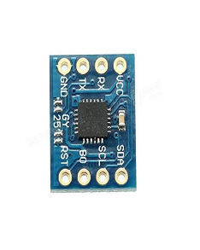
- GY-25 for compass
This component equips the robot with the ability to discern its current orientation, thereby enabling it to determine the appropriate direction for turning.

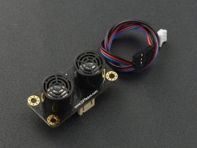
- Gravity URM 09 for Ultrasonic sensor
The ultrasonic sensor plays a crucial role in guiding the robot's navigation by detecting distances between the robot and obstacles.

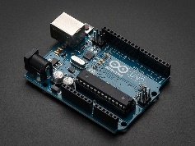
- Arduino UNO for the controller board
The Arduino UNO controller acts as the pivotal point where we upload our robot's program, effectively functioning as the brain of our creation.

- Arduino Sensor Shield V5.0 and Shield L298P Motor Driver with GPIO for extension board
Both of these shields serve a similar purpose by offering additional ports that enable our robot to connect with motors, sensors, and batteries.
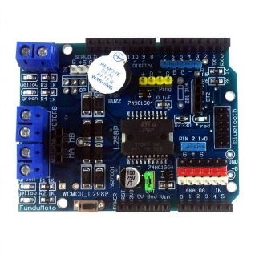
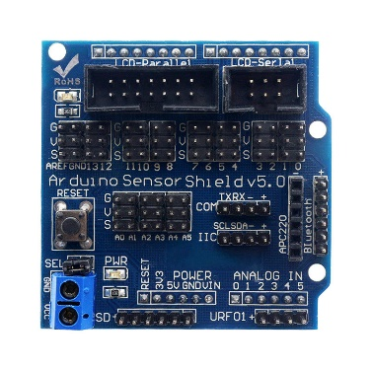
Sensor Shield Motor Shield

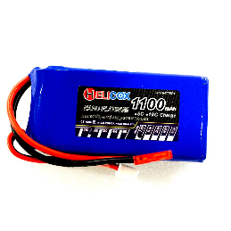
- Helicox 1100 mAh (7.4V) for our robot battery
Our robot power source, last around 1 hour

Wiring
#Motor
ENB -> Arduino UNO Pin 11
INB -> Arduino UNO Pin 13
#Servos
STEER_SRV -> Arduino UNO Pin 9
ULTRA_SRV -> Arduino UNO Pin 8
#Ultrasonic Sensor
ULTRA_DATA_PIN -> Arduino UNO Pin 2
#Light Sensors
RED_DATA_SEN -> Arduino UNO Pin 0
BLUE_DATA_SEN -> Arduino UNO Pin 1
#Button
BUTTON_DATA -> Arduino UNO Pin 3
#Pixy Camera
PIXY_SDA -> Arduino UNO Pin 4
PIXY_SCL -> Arduino UNO Pin 5
#Gryo
TX -> Arduino UNO RX
RX -> Arduino UNO TX
#Battery
BATTERY -> PWR_IN of Arduino UNO

2.3 Evading obstacle
2.3.1 Qualification round
In this round, we will use the ultra sonic sensor to calculate the distance of robot and the wall to not be too close or too far

Simulation if the black is the robot and the big square is the wall, the robot will keep on the
distance with the wall

The robot will keep on the range with the wall by calculating gyro sensor to steering degree and it will make the robot maintain distance with the wall with PID for short or Proportional Integral Derivative.

Program for walking
2.3.2 The final round
In the final round, we use camera, gyro, and ultrasonic to calculate the steering degree

The robot will still use PID but it will add the avoidance degree

These are the code:
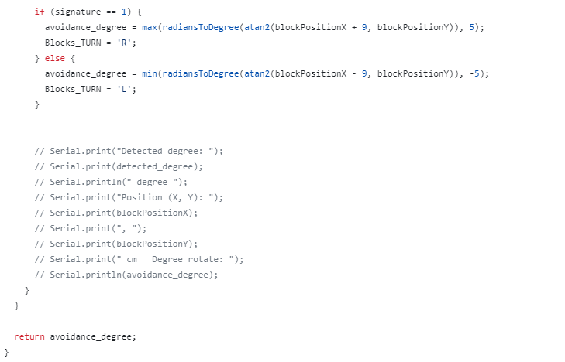
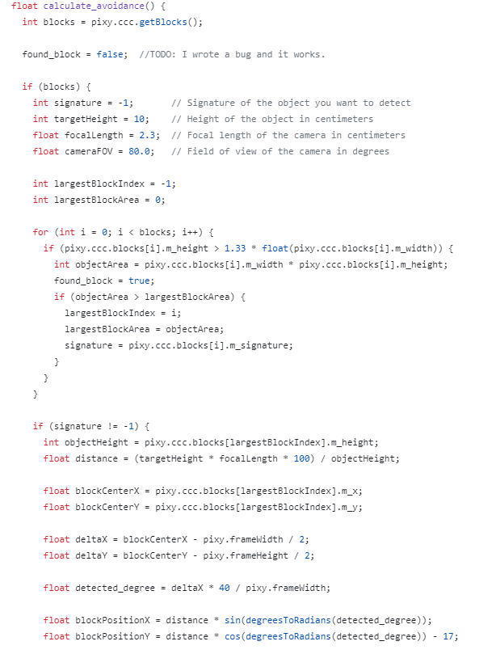

2.4 Engineering factor
We designed this robot specifically for this competition by using Lego parts mixed up with the bolt, tape, and Arduino parts.

The problem about our robot.
- Since the robot use a lot of sensor for example, color sensor, camera, motor, and etc. We need to change the battery very often,
- Since the battery went out very quick, and the Li-po battery doesn’t have battery indicator we need to check very often for battery life and safety
- When we were designing the robot, there are problem that two side of the robot is not equal
So it make the robot hard to design

3. Github Link
https://github.com/Snackels/WRO_Future-Engineer

4. YouTube Link
https://youtu.be/MBe6ZsyGE-E

